Mathematic 7
General Study Reference Guide
Guide Notes

Chapter 5, “Operations With fractions”
- Students should be able to identify a numerator and denominator
- Write addition and subtraction statements when given a number line example.
Adding Two Fractions with the Same Denominators:
1.) 3/10 + 6/10 = 9/10

2.) 6/10 + 8/10 = 14/10 * Reduce the fraction to its simplest form.

• Divide the denominator 10 into the numerator 14;
14 ÷ 10 = 1 with 4 remaining.
The 1 represents one full unit, 4 represents 4 parts of a unit with 10 parts.
• 1 4/10 = 1 2/5

Adding Two Fractions with Different Denominators:
Strategy #1: Try dividing the lowest denominator into the higher denominator.

3.) 2/5 + 5/10 = 9/10 How did we arrive at the answer?

• 10 ÷ 5 = 2, therefore 5 x 2 = 10. 10 is the common denominator.

Multiply the numerator by 2, then multiply the denominator by 2

• 2 x 2 = 4 * 2/5 and 4/10 are equivalent fraction

• 4/10 + 5/10 = 9/10

4.) 5/9 + 1/3 = 8/9 How did we arrive at the answer?

• 9 ÷ 3 = 3, therefore 3 x 3 = 9. 9 is the common denominator.

Multiply the numerator by 3, then multiply the denominator by 3

• 1 x 3 = 3
3 x 3 = 9

• 5/9 + 3/9 = 8/9

5.) 3/4 + 17/20 = 1 12/20 How did we arrive at the answer?

• 20 ÷ 4 = 5, therefore 4 x 5 = 20. 20 is the common denominator.

Multiply the numerator by 5, then multiply the denominator by 5

• 3 x 5 = 15
4 x 5 = 20
• 15/20 + 17/20 = 32/20 * Reduce the fraction to its simplest form.
• Divide the denominator 20 into the numerator 32; 32 ÷ 20 = 1 with 12 remaining.
Fraction portion
• 32/20 = 1 12/20 = 12/20 ÷ 4 (numerator and denominator) = 1 3/5

Strategy #2: Least Common Multiple – Denominator
6.) 4/7 + 1/10 = 47/70 How did we arrive at the answer?
Multiples of 7: 7, 14, 21, 28, 35, 42, 49, 56, 63, 70, 77, ...
Multiples of 10: 10, 20, 30, 40, 50, 60, 70, 80, 90, ...
70 is the least common multiple
• 70 ÷ 7 = 10 * 7 is the denominator of the first fraction
4 x 10 = 40
7 x 10 70

40/70
• 70 ÷ 10 = 7 * 10 is the denominator of the first fraction
1 x 7 = 7
10 x 7 = 70

7/70
• 40/70 + 7/70 = 47/70 * Reduce the fraction to its simplest form, if possible.

Strategy #3: Multiply the denominators of the two fractions. The product is the new common denominator.
7.) 3/5 + 5/6 = 1 13/30 How did we arrive at the answer?

• 5 x 6 = 30, 30 is a common denominator. Adjust the fractions accordingly
• 30 ÷ 5 = 6 * 5 is the denominator of the first fraction
3 x 6 = 18
5 x 6 = 30

18/30
• 30 ÷ 6 = 5 * 6 is the denominator of the first fraction
5 x 5 = 25
6 x 5 = 30

25/30
• 18/30 + 25/30 = 43/30 * Reduce the fraction to its simplest form.
• Divide the denominator 30 into the numerator 43;
43 ÷ 30 = 1 with 13 remaining.
• 43/30 = 1 13/30
Subtracting Two Fractions:
The strategies for subtracting two fractions are the same as the strategies for adding fractions. A common denominator must be found, then, instead of adding subtract the numerators and put it over the common denominator. Use the strategies listed above in the addition section to find a common denominator.
1.) 7/4 – 2/3 = 1 1/12 * How did we arrive at the answer?

• 4 x 3 = 12, therefore, 12 is the common denominator.
• 7 x 3 = 21
4 x 3 = 12

21/12
• 2 x 4 = 8
3 x 4 = 12

8/12
• 21/12 – 8/12 = 13/12 * Reduce the fraction to its simplest form.
• Divide the denominator 12 into the numerator 13;
13 ÷ 20 = 1 with 1 remaining.
• 13/12 = 1 1/12

Adding Mixed Fractions
1.) 3 5/7 + 10 1/7 = 13 6/7

2.) 5 4/5 + 7 3/5 = 12 2/5

Whole #: 5 + 7 = 12
Numerators: 4/5 + 3/5 = 7/5 = 1 2/5

Sum: 12 + 1 2/5 = 13 2/5

3.) 2 3/4 + 3 1/5 * multiply the denominators to find a common denominator
4 x 5 = 20 (common denominator)
3 x 5 =15 (new numerator first fraction)
1 x 4= 4 (new numerator second fraction)
2 15/20 + 3 4/20 =
Whole #: 2 + 3 = 5
Numerators: 15/20 + 4/20 = 19/20

Sum: 12 19/20

4.) 10 5/6 + 9 2/3
6 ÷3 = 2 * multiply the lowest denominator by two (2)

2/3; 2 x 2 =4 and

10 5/6 + 9 4/6 =
Whole #: 10 + 9 = 19
Numerators: 5/6 + 4/6 = 9/6 = 1 3/6 =

Sum: 19 + 1 3/6 = 20 3/6 * reduce to simplest form. 20 1/2

Subtracting Mixed Fractions
1.) 4 3/4 - 3 2/4 =
Whole #: 4 - 3 = 1
Numerators: 3/4 – 2/4 = 1/4

Difference: 1/4

2.) 7 2/5 - 3 4/5 =

We can not subtract 4/5 from 2/5. Therefore, we need to borrow from
the whole number one full unit of five. Thus, we take 1 unit of five
from 7 leaving 6 whole units. Then we add the unit of 5 to the
numerator 2 to equal 7
6 7/5 - 3 4/5 =

Difference: 3 3/5
3.) 8 1/2 - 4 1/8 =
8 ÷2 = 4 * multiply the lowest denominator by four (4)
1 x 4 = 4
2 x 4 = 8
Whole #: 8 - 4 = 4
Numerators: 4/8 - 1/8 = 3/8

Difference: 4 3/8

4.) 5 4/10 - 3 9/10 =
10 ÷5 = 2 * multiply the lowest denominator by two (2)
4 x 2 = 8
5 x 2 = 10
5 8/10 - 3 9/10 =

We can’t subtract 9/10 from 8/10. Therefore, we need to borrow
from the whole number one full unit of 10. Thus, we take 1 unit of
ten from 5 leaving 4 whole units. Then we add the unit of 10 to the
numerator 8 to equal 18
4 18/10 - 3 9/10 =

Whole #: 4 - 3 = 1
Numerators: 18/10 – 9/10 = 9/10
Difference: 1 9/10

Another way to add and subtract mixed fractions:
- Find a common denominator for both fractions, convert each mixed fraction
to an improper fraction, then add or subtract, accordingly.
Ex.1
5 4/5 + 2 3/5 =
5 4/5 = 29/5
2 3/5 = 13/5
29/5 + 13/5 = 42/5 = 8 2/5
Ex. 2
7 5/10 – 3 4/10 =
7 5/10 = 75/10
3 4/10 = 34/10
75/10 + 34/10 = 109/10 = 10 9/10
Chapter 6, “Equations”
- Identify the numerical coefficient, constant term, variable and solution in an expression or equations.
- Students are encouraged to review strategies to solving equations, as per teacher’s handout:
A) Inspection
B) Systematic Trial
C) Balance Scale Method
D) Algebra Tiles Method
E) Algebra

Expressions:
1. A) 45p - 11
B) 9 + y
C) 32x
D) d + d + d
E) Seven more than a number. x + 7
F) A number decreased by twenty three. p - 23
G) A number split nine ways. n/9
H) Six times a number. 6t
Equations:
2. A) 7 + t = 32
B) c+ c + c + c + c = 5c
C) 35k + 11 = 186
D) 18 - q = 11
E) 4r = 50
F) The difference between two numbers is fifteen. n - s = 15
G) Thirty divided by a number is ten. 30/n = 10
H) A number increased by eleven is eighty one. n + 11 = 81
I) Five more than three times a number is seventeen. 3b + 5 = 17
Solving Equations:

3.) 12 + s = 40
12 - 12 + s = 40 - 12
s = 28

4.) n + n + n + n = 20
4n = 20
4n = 20
4n/4 = 20/4
n = 5

5.) 2x + 6 = 26
2x + 6 - 6 = 26 - 6
2x = 20
2x = 20
2 2
x = 10

Word Problems:

6.) Jonathan collects ancient coins. If he sells sixteen coins and has sixty seven left, how many coins did he start have before he sold some?

c - 16 = 67
c - 16 + 16 = 67 + 16
c = 83

* Jonathan had eighty three ancient coins before he sold sixteen.

7.) Jennifer bought a loose bag of jelly beans for fifty cents. She counted fifty seven jelly beans in the bag. She ate twelve and equally split the rest of the jelly beans among her five friends. How many jelly beans did each friend receive?

(57 - 12) ÷ 5 = j
45 ÷ 5 = j
9 = j
* Jennifer’s five friends received nine jelly beans each.

Extra Example 1:
3n + 6 = 18
Step 1: Take away the constant term (6) from both sides of the equation
3n = 12
Step 2: Divide both sides of the equation by the numerical coefficient (3).
3n/3 = 12/3
n = 4
Extra Example 2:
a) Five more than a number is thirteen
n + 5 = 13
n = 8
b) A number increase by six is twenty-one.
n + 6 = 21
n = 15
Chapter 7,”Data Analysis”
* Mean mode and median are measures of "central tendency".
Set of numbers: 2, 20, 40, 6, 4, 10, 8, 20
Step 1: Organize the set of numbers
2, 4, 6, 8, 10, 20, 20, 40
Step 2: How many numbers are in the set?
* There are eight (8) numbers in the set.
Step 3: Calculate the range by subtracting the least number from the greatest.
40 - 2 = 38
* The range is 38
Step 4: Identify the outlier (The number which is significantly different from the others. There can be more than one outlier).
* 40 is the outlier it is 20 units away from the closest number in the set.
* Students should be able to calculate the mean with and without the outlier.
Step 5 Find the mode (The number which appears most often. There can be more than one mode)
* 20 is the mode
Step 6: Find the median (The middle number in the organized set. If the data set has two middle numbers, add the two numbers, then divide the sum by two, in order to find the median.)
* 8 and 10 are the middle number. Add 8 and 10 together, then divide by 2 to find the median.
8 + 10 = 18; 18/2 = 9
* 9 is the median
Step 7: Calculate the mean (Add the numbers of the set then divide by the sum by the amount of numbers in the set.
* 2 + 4 + 6 + 8 + 10 + 20 + 20 + 40 = 110; 110/8 = 13.75
* Verify: 13.75 x 8 = 110
* The mean is 13.75
Probability:
The likelihood of a particular event; the number of times a particular
outcome will occur.

The probability that an impossible event will occur is 0, 0%.

The probability that a certain event will occur is 1, or 100%.

The number of outcomes favorable to that event
Number of possible outcomes

Word Problem -
Jonathan has a box of 25 jellybeans. Each box of jellybeans has 5 orange, 5 green, 10 yellow and 3 blue and 2 black jellybean. What are the chances of Jonathan reaching in and selecting the various colors of jelly beans on the first attempt?

Orange
5/25 = 0.2 x 100 = 20%;

• Five out of twenty-five chance of selecting an orange jelly bean.

• A 20% chance of selecting an orange jelly bean.

• A 20 out of 100 chance of selecting an orange jelly bean.

• A 2 out of 10 chance of selecting an orange jelly bean.

Green
5/25 = 0.2 x 100 = 20%;

Yellow
10/25 = 0.4 x 100 = 40%;

Blue
3/25 = 0.12 x 100 = 12%;

Black
2/25 = 0.08 x 100 = 8%;

Independent Events:
< Two events are independent events if the result of one event does not depend on the result of the other event.

Ex. The toss of two coins. The toss of the first coin will reveal either a heads or a tails. The first toss does not influence the results of the second toss.

Word Problem -
Sarah is planning on going to her best friend’s birthday party. She is deciding on what to wear. She has three shirts (Blue, Green and Red). She also has two skirts (Long and short). What is the
probability that Sarah will select a long skirt with a green shirt?

Create a chart to help answer the question.

Sarah’s Wardrobe Choices

 | Shirts
Skirts |  | Blue | Green | Red
Skirts | Long | Long/Blue | Long/Green | Long/Red
Skirts | Short | Short/Blue | Short/Green | Short/Red
Ratio: 1:6
Fraction: 1/6
_
Decimal 0.16
_ _ _
Percentage: 0.16 x 100 = 16.6; 16.6%
Sentence: Sarah has a 1 out of 6 chance of selecting a long skirt with a green shirt.

- Alternate method: Tree diagram

** Important Note:
While it is important to develop mental math skills - the ability to arrive at correct answers in one’s mind without doing pencil paper computations - it is equally important that students are able to demonstrate their math ability and understanding by showing all workings. The examples above are a great reference on how to show one’s working.
Chapter 8,”Geometery”
__
A line segment AB
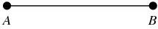

Parallel lines are lines on a flat surface that never meet. There are several methods to create parallel lines, including: paper fold, ruler, ruler and protractor and ruler and compass.
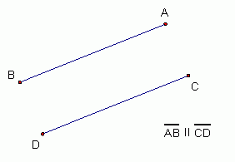

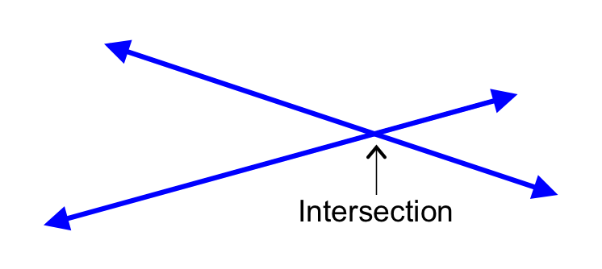
Lines intersect if they cross each other.

A line which divides (bisects) a segment into two equal parts is a bisector.
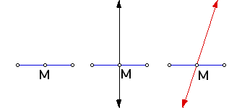

A line which bisects a segment at 90⁰ is a perpendicular bisector. There are several methods to create parallel lines, including: paper fold, ruler, ruler and protractor, ruler and compass and Mira.
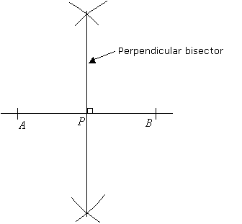

An angle which measures less than 90⁰ is an acute angle.
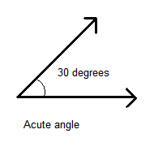
The point where two segments intersect to create an angle is called a vertex.
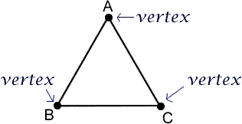
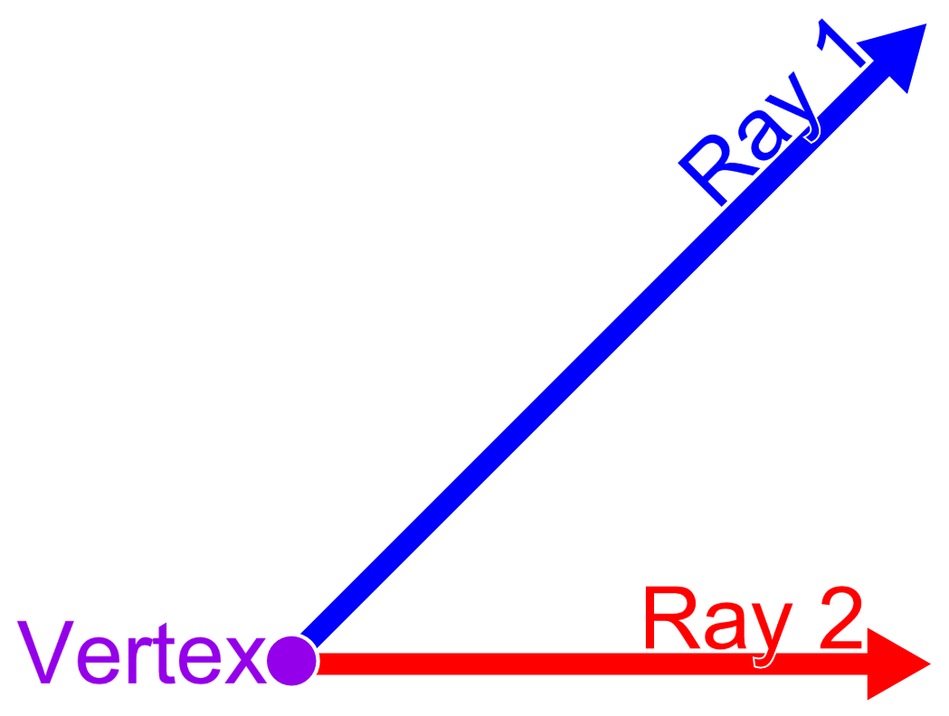
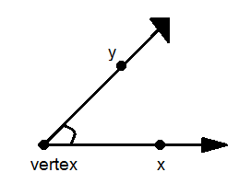

The point at which perpendicular bisectors of the sides of a triangle intersects is called the circumcenter.
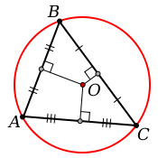

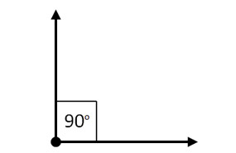
An angle which measures 90⁰ is a right angle.

An angle which measures greater than 90⁰, but less than 180⁰ is an obtuse angle.
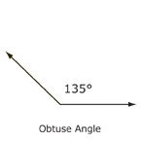
An angle which measures greater than 180⁰, but less than 360⁰ is a reflex angle.
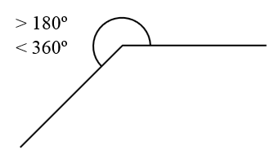

An angle measuring 360⁰ creates a circle.
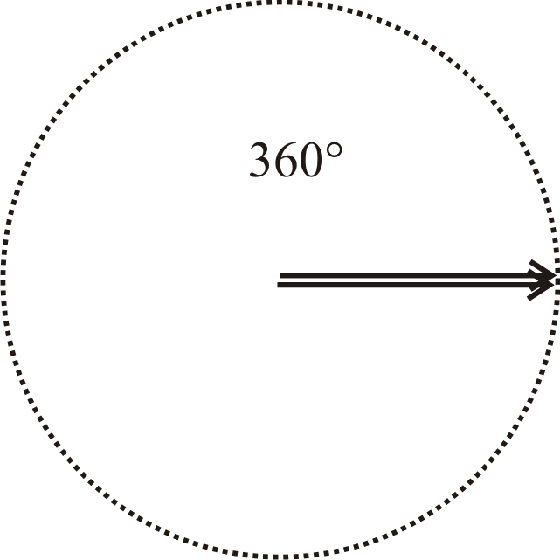

A line which bisects an angle into two equal parts is called an angle bisector.

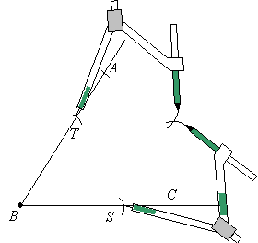

The angles of isosceles, scalene and equilateral triangles can be bisected.

Coordinate Grid

On a grid, the horizontal line is the x axis, while the vertical line is the y axis.
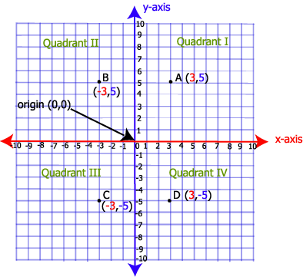

The x and y axis intersect at a 90⁰ angle, creating a coordinate grid (Cartesian Plane) with four quadrants. Quadrant 1 (+,+), Quadrant 2 (-,+), Quadrant 3 (-,-) and quadrant 4 (+,-).

Arrows are not needed on the coordinate grid.

Coordinated are points on the grid identified by an x and a y reference. A pair of coordinates is called an ordered pair.

The x and y axis intersect at coordinates (0,0) called the origin.

Shapes on the coordinate grid can be rotated, reflected or translated. Reflections and translations are transformations. Each point on the new image is a prime; A’.

Rotations:

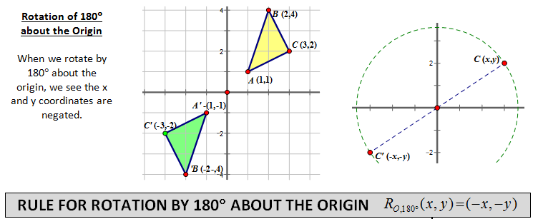

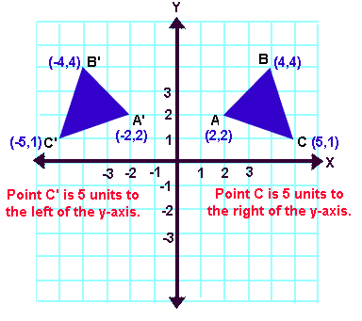
Reflections:

Translation:
