Mathematic 7
Chapter 8, “Geometry”
Guide Notes

__
A line segment AB
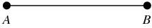

Parallel lines are lines on a flat surface that never meet. There are several methods to create parallel lines, including: paper fold, ruler, ruler and protractor and ruler and compass.
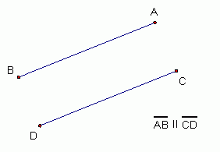

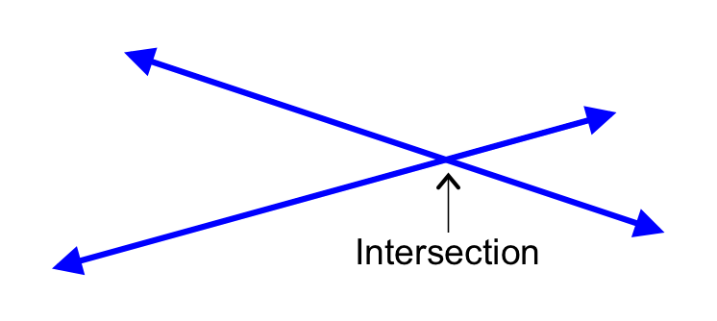
Lines intersect if they cross each other.

A line which divides (bisects) a segment into two equal parts is a bisector.
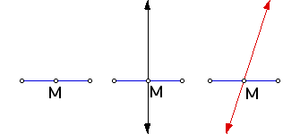

A line which bisects a segment at 90⁰ is a perpendicular bisector. There are several methods to create parallel lines, including: paper fold, ruler, ruler and protractor, ruler and compass and Mira.
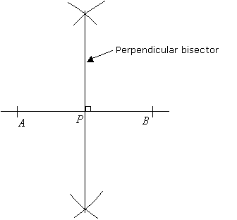

An angle which measures less than 90⁰ is an acute angle.
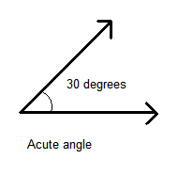
The point where two segments intersect to create an angle is called a vertex.
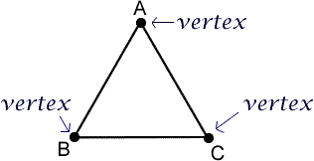
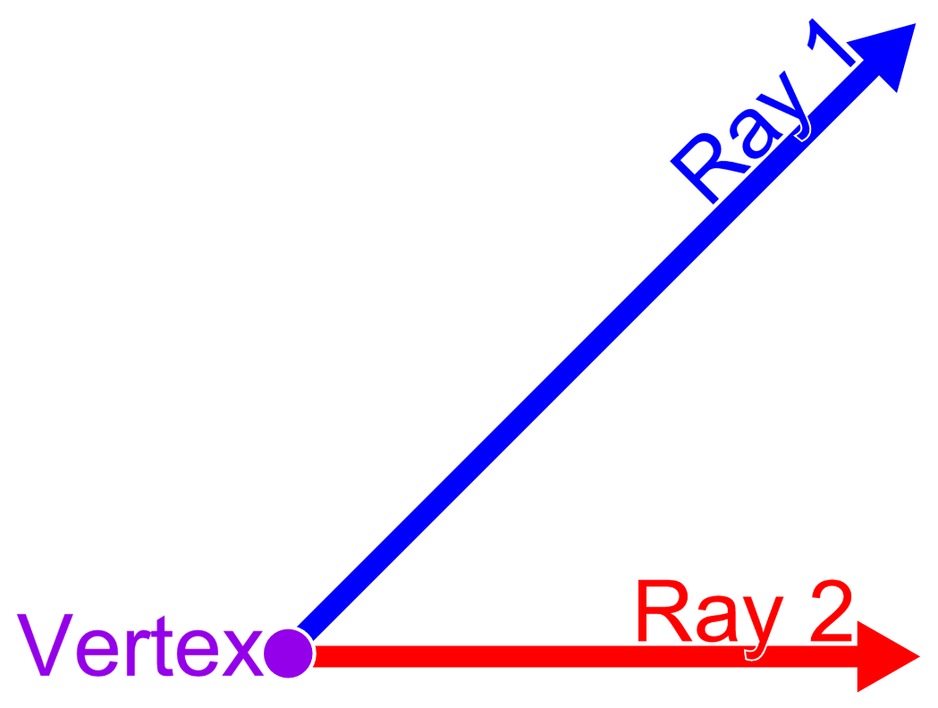
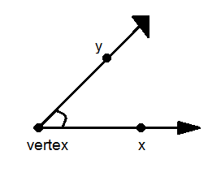

The point at which perpendicular bisectors of the sides of a triangle intersects is called the circumcenter.
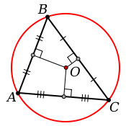

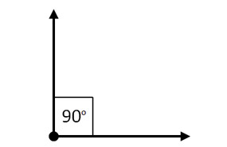
An angle which measures 90⁰ is a right angle.

An angle which measures greater than 90⁰, but less than 180⁰ is an obtuse angle.
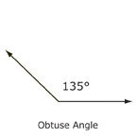
An angle which measures greater than 180⁰, but less than 360⁰ is a reflex angle.
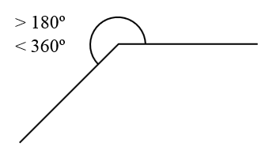

An angle measuring 360⁰ creates a circle.
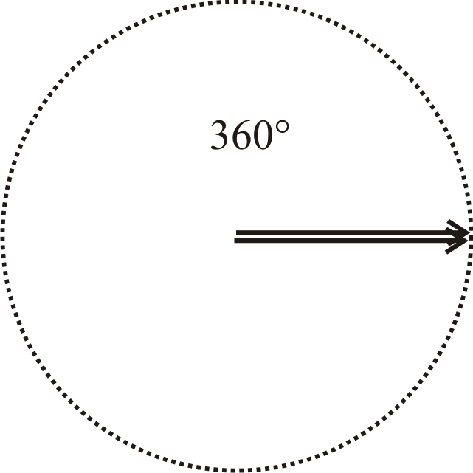

A line which bisects an angle into two equal parts is called an angle bisector.

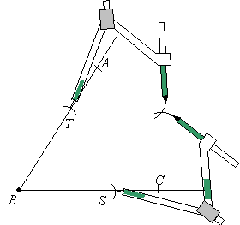

The angles of isosceles, scalene and equilateral triangles can be bisected.

Coordinate Grid

On a grid, the horizontal line is the x axis, while the vertical line is the y axis.
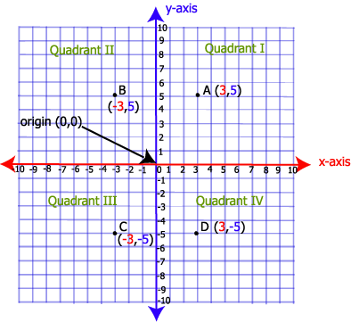

The x and y axis intersect at a 90⁰ angle, creating a coordinate grid (Cartesian Plane) with four quadrants. Quadrant 1 (+,+), Quadrant 2 (-,+), Quadrant 3 (-,-) and quadrant 4 (+,-).

Arrows are not needed on the coordinate grid.

Coordinated are points on the grid identified by an x and a y reference. A pair of coordinates is called an ordered pair.

The x and y axis intersect at coordinates (0,0) called the origin.

Shapes on the coordinate grid can be rotated, reflected or translated. Reflections and translations are transformations. Each point on the new image is a prime; A’.

Rotations:

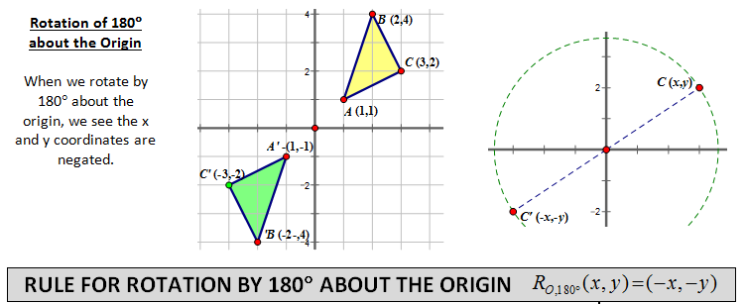

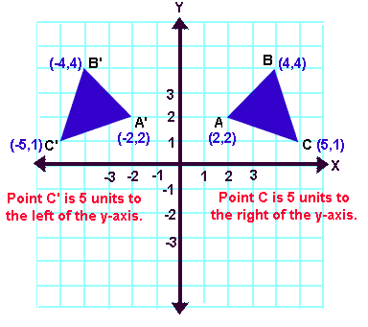
Reflections:

Translation:
