Mathematics 7
Chapter 8, “Geometry”
Rotations

1.) Plot the following points of : A (-5,-3), B (-3,-7) and C (-7,-7).
2.) Rotate triangle ABC 70⁰ counter-clockwise around A.

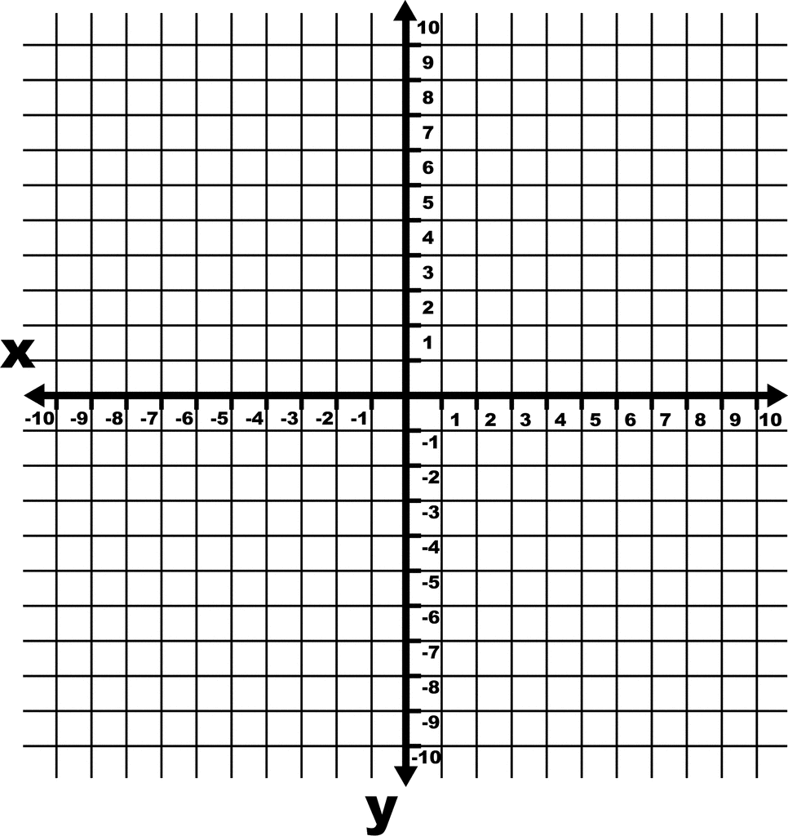

Mathematics 7
Chapter 8, “Geometry”
Assignment - Rotations

1.) Plot the following points to create triangle ABC. : A (-2,2), B (-6,5) and C (-4,1).
2.) Rotate triangle ABC 120⁰ clockwise around the origin.

