Mathematics 7
Chapter 8, “Geometry”
Assignment - Translations

1.) Plot the following points of : A (5,6), B (6,2) and C (2,3).
2.) What quadrant is the image found?
3.) Translate the image six spaces to the left and eight spaces down.
4.) Plot the coordinates of the new image. 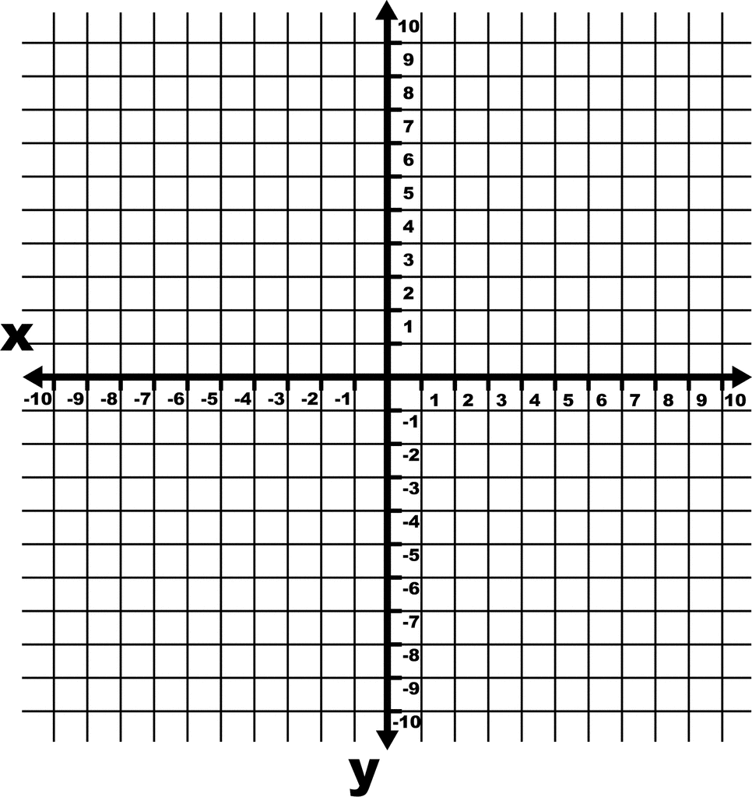

Mathematics 7
Chapter 8, “Geometry”
Assignment - Reflections

1.) Plot the following points to create triangle ABC. : A (-2,2), B (-6,5) and C (-4,1).
2.) What quadrant is triangle ABC found?
3.) Reflect triangle ABC on the X, then on the Y-axis.

